**CaptBooks**

Premium Indian Online Bookstore

**Technical Documentation & Architecture**

React 18 • Tailwind CSS • Firebase • Framer Motion

December 2024  
By CaptFlag

# 📋 Table of Contents

1. Executive Summary

2. Technology Stack & Rationale

3. System Architecture Overview

4. Application Screenshots

5. User Shopping Flow

6. State Management Architecture

7. Component Hierarchy

8. Database Design (ERD)

9. Authentication Flow

10. Order Processing Flow

11. Analytics Data System

12. Performance Optimizations

13. Future Roadmap

# 📌 Executive Summary

CaptBooks is a modern, full-featured online bookstore built specifically for the Indian market. The platform combines cutting-edge frontend technologies with robust Firebase backend services to deliver a premium e-commerce experience for book enthusiasts across India.

## Key Highlights

**• Modern Stack:** React 18, Vite, Tailwind CSS 4.0, Framer Motion

**• Premium UI/UX:** 3D animations, page transitions, toast notifications

**• Indian Market:** INR currency, Indian authors, localized content

**• Real-time Data:** Firebase Authentication & Cloud Firestore

**• Analytics:** Comprehensive dashboard with sales insights

**• Responsive:** Mobile-first design for all devices

# 🛠️ Technology Stack & Rationale

Each technology was carefully selected based on performance, developer experience, and ecosystem support. Here's a detailed breakdown:

## Frontend Technologies

|  |  |  |
| --- | --- | --- |
| **Technology** | **Version** | **Why We Chose It** |
| React 18 | 18.3.1 | Component architecture, hooks API, virtual DOM, massive ecosystem |
| Vite | 6.0.1 | Instant dev server, HMR, faster builds than webpack |
| Tailwind CSS | 4.0.0 | Utility-first, CSS-native config, smaller bundles |
| Framer Motion | 11.x | Declarative animations, gestures, layout animations |

## Backend Technologies

|  |  |  |
| --- | --- | --- |
| **Technology** | **Version** | **Why We Chose It** |
| Firebase Auth | 11.x | Email/password + Google OAuth, session management |
| Cloud Firestore | 11.x | NoSQL, real-time sync, offline support, auto-scaling |

# 🏗️ System Architecture Overview

The application follows a modern layered architecture with clear separation of concerns:

**System Architecture Diagram**

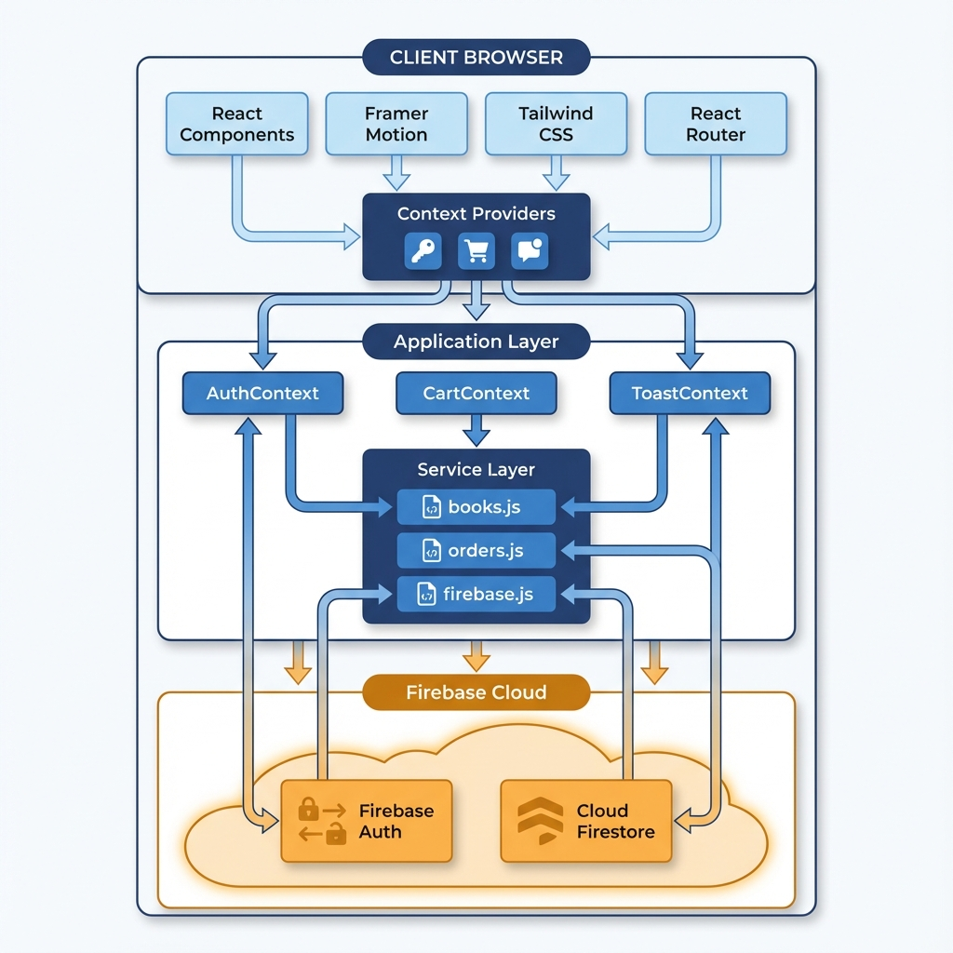

# 🖼️ Application Screenshots

## Home Page

The homepage features a premium hero section with floating book animations, a horizontal scrollable carousel of featured books, and a showcase of top Indian authors with animated gradient rings.

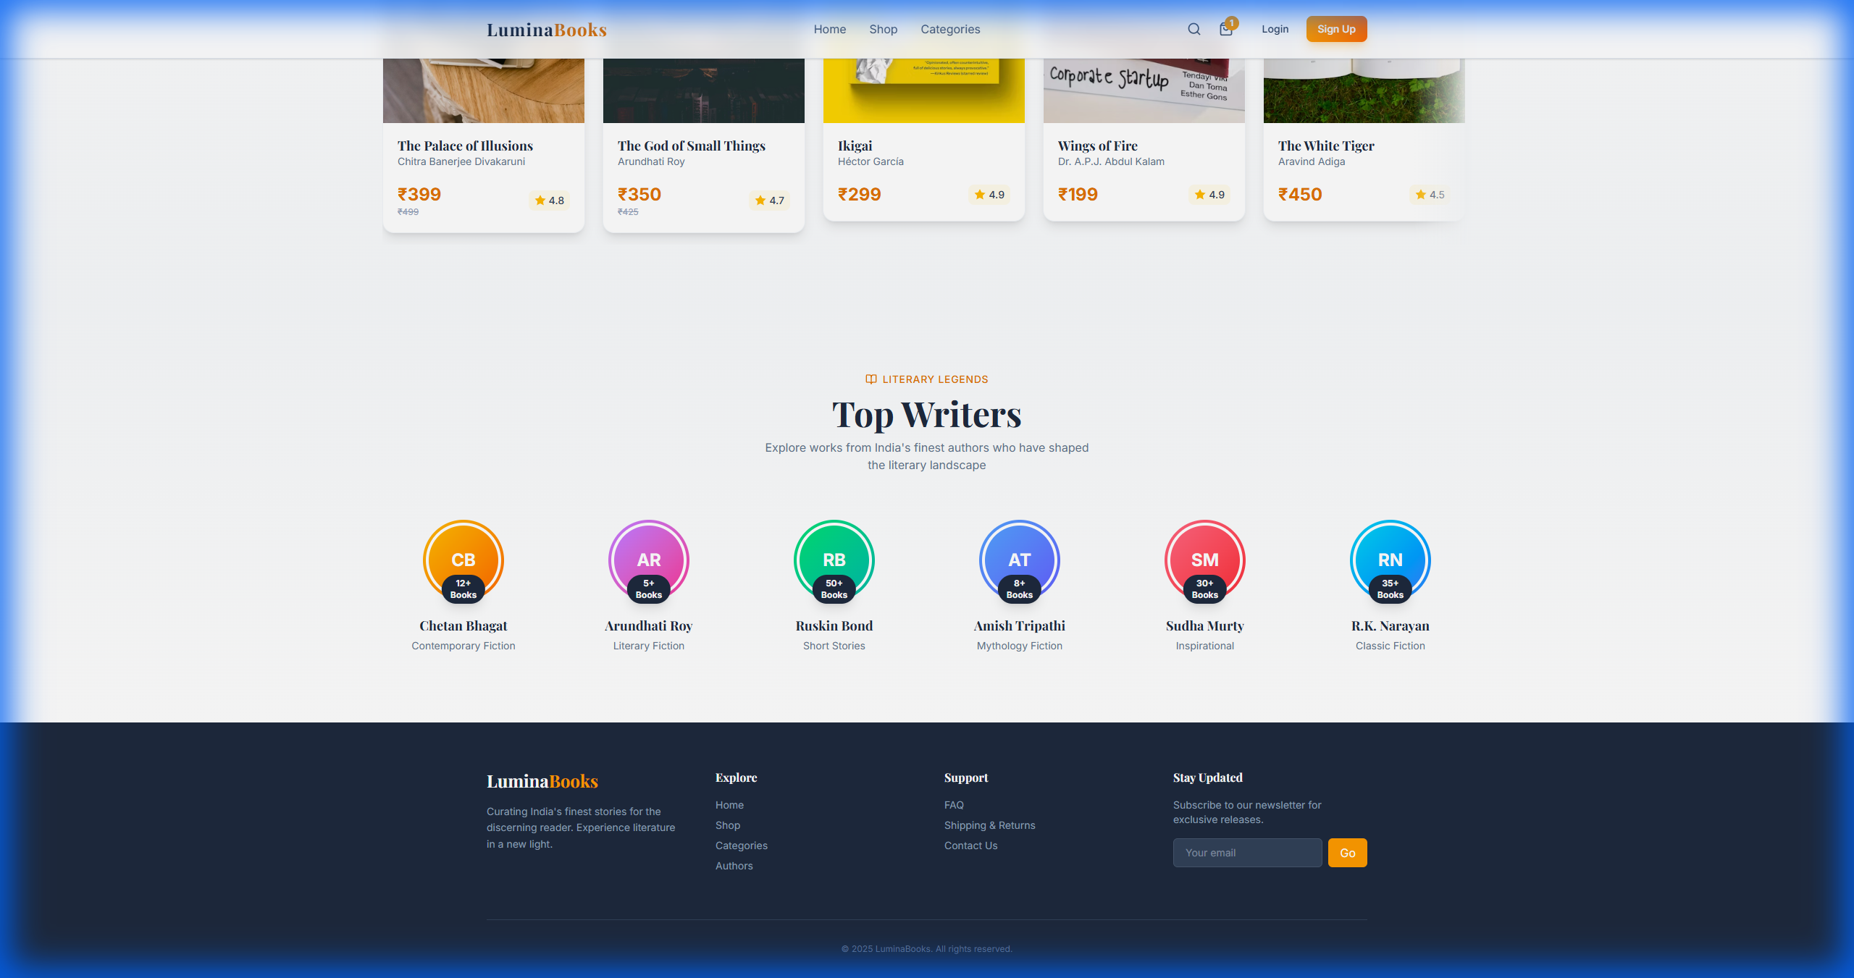

## Shop Page

The shop displays all books with category filters, price range selection, and 3D tilt effect on book cards. Users can easily add items to cart.

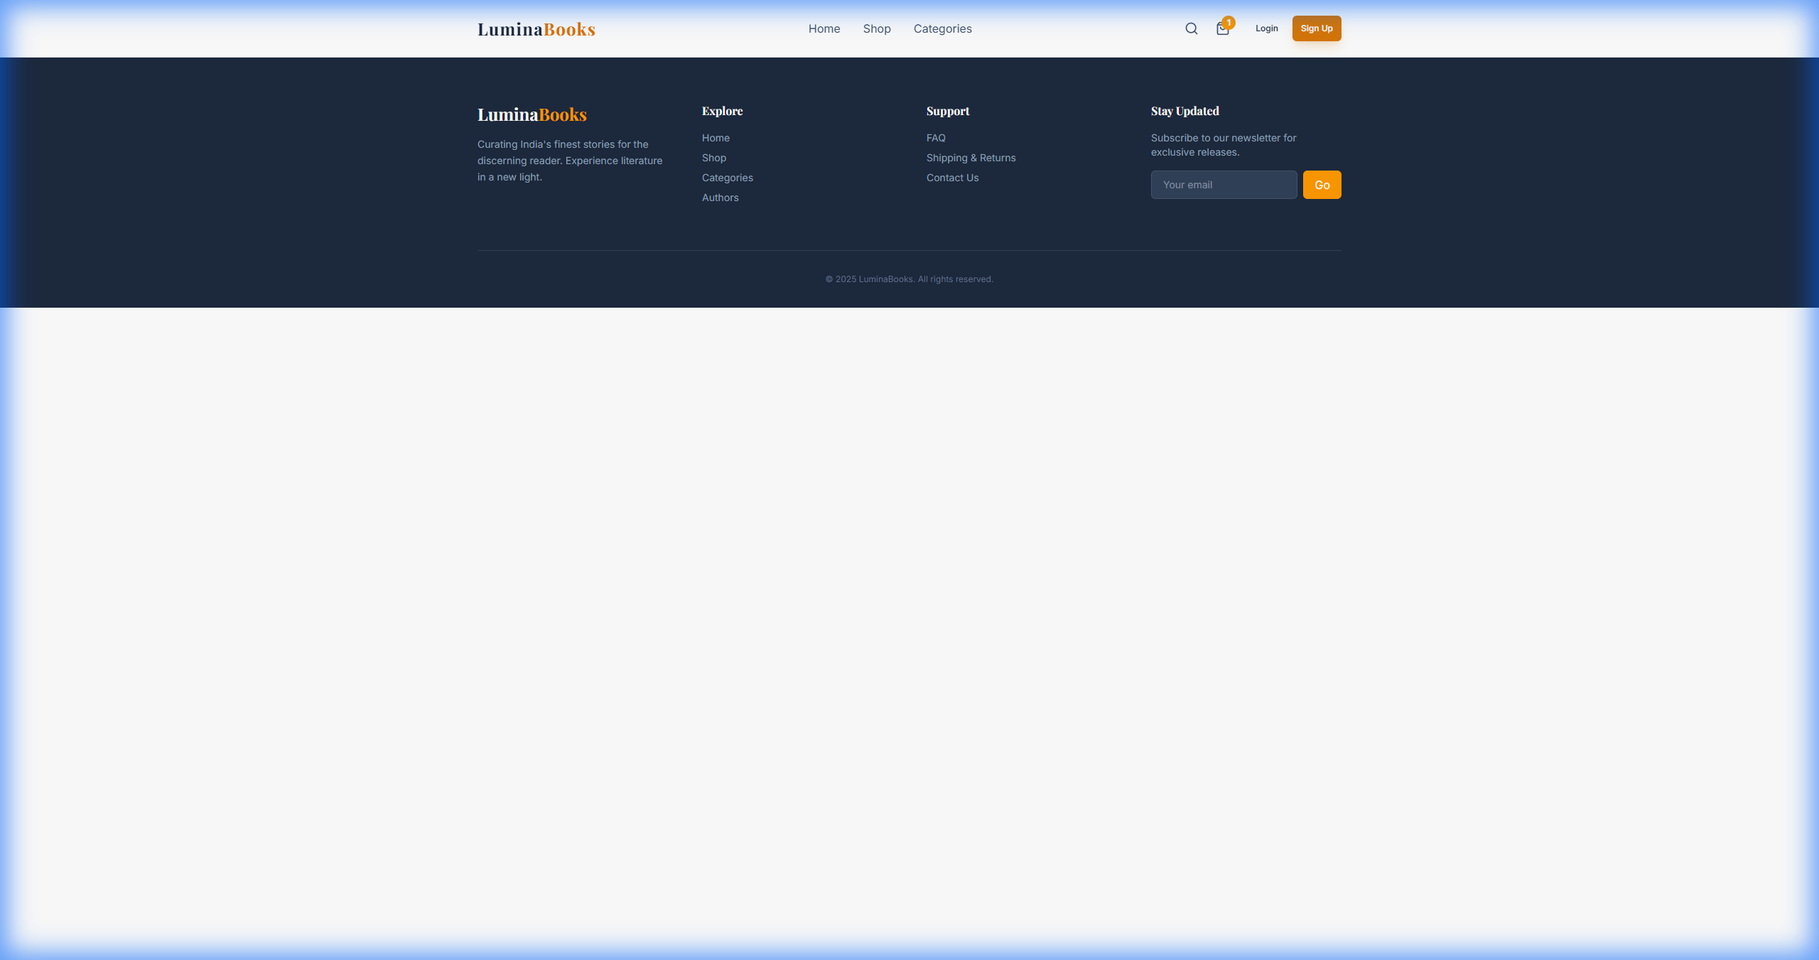

## Cart Page

The shopping cart shows all selected items with quantity controls, individual prices, and a comprehensive order summary with checkout button.

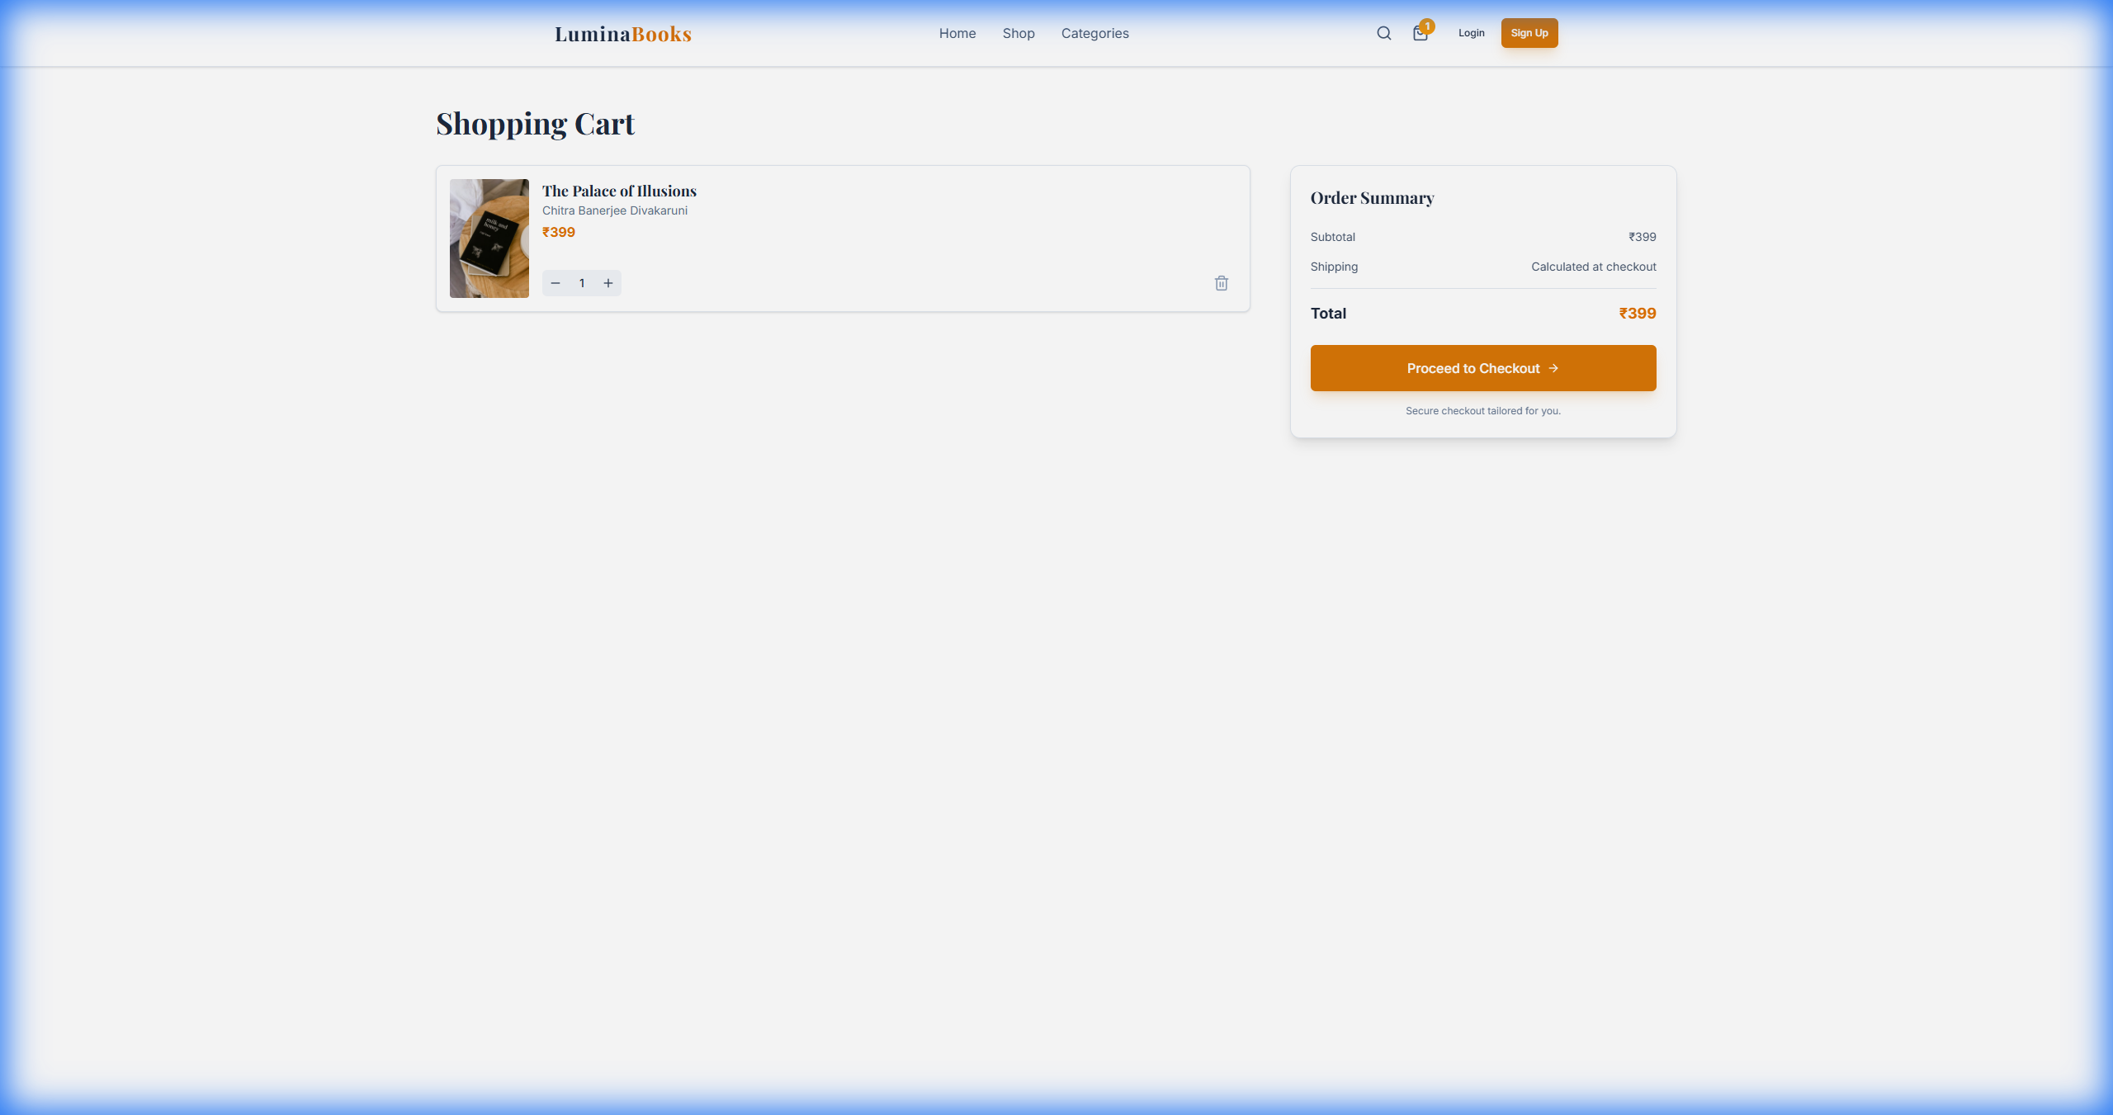

## Admin Analytics Dashboard

The admin dashboard provides comprehensive business analytics including revenue trends, top-selling books, category breakdown, customer insights, and geographic distribution of orders.

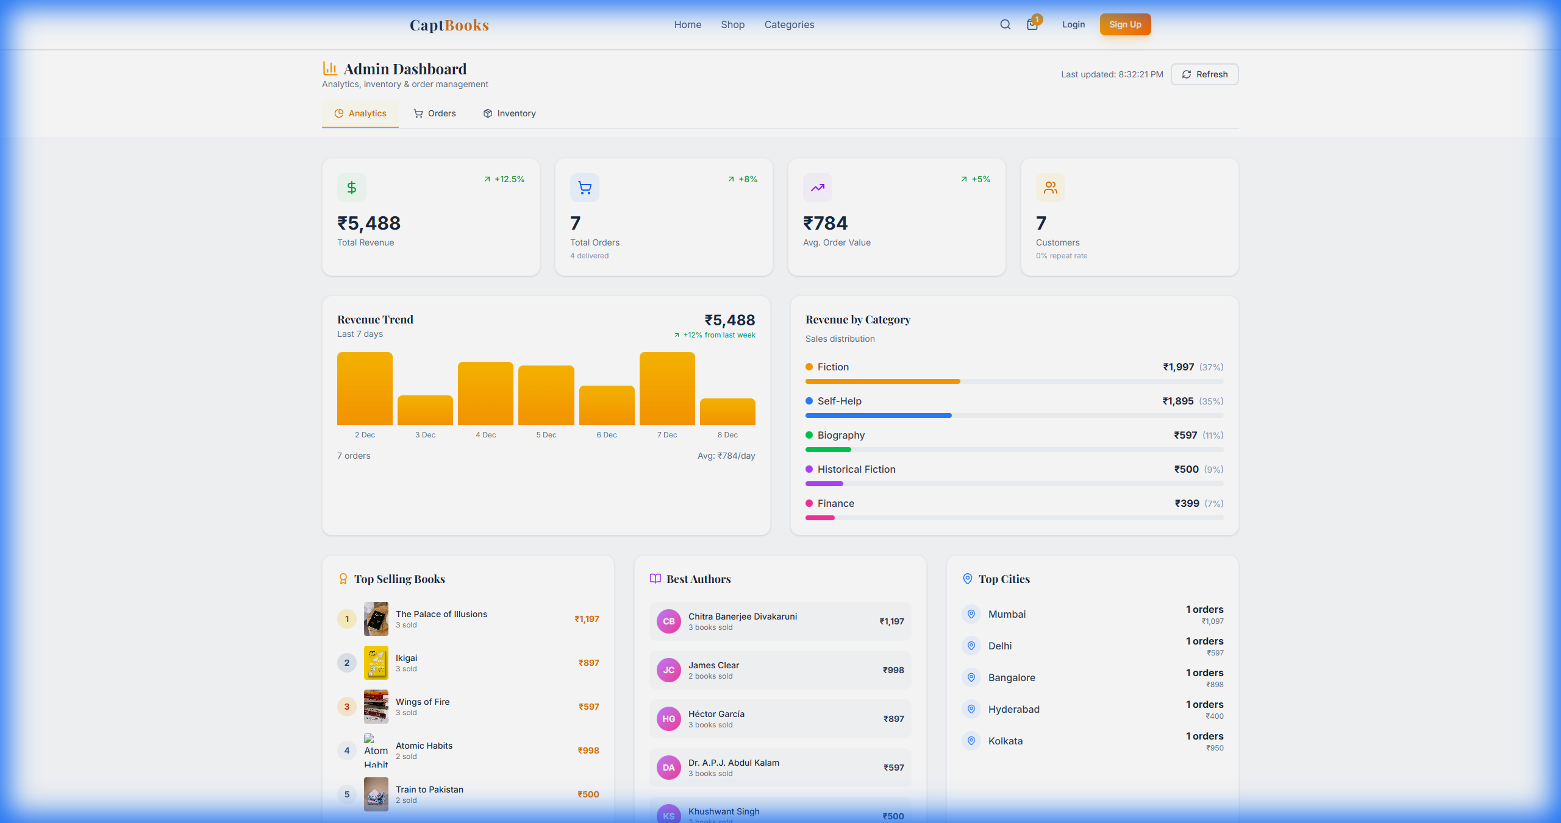

# 🛒 User Shopping Flow

The following diagram illustrates the complete user journey from browsing to purchase:

**Shopping Flow Diagram**

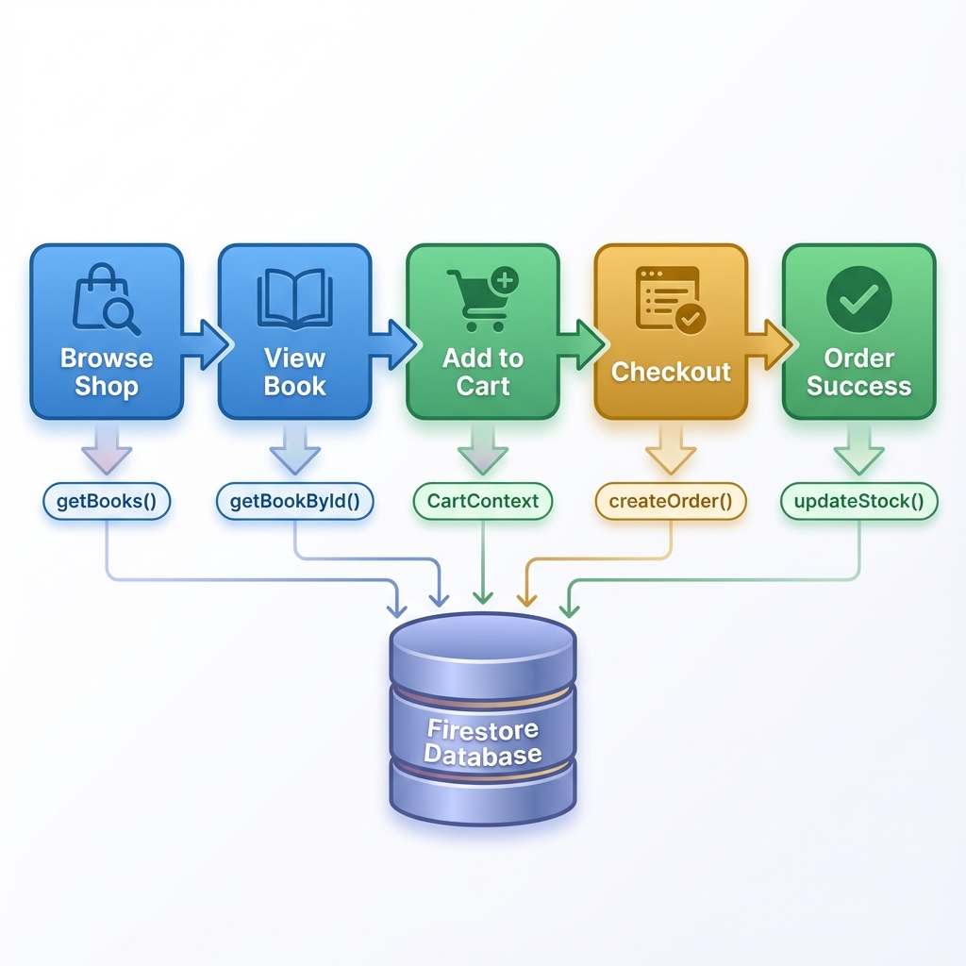

# ⚡ State Management Architecture

The application uses React Context API for global state management, avoiding the complexity of Redux while maintaining clean state flow:

**State Management Diagram**

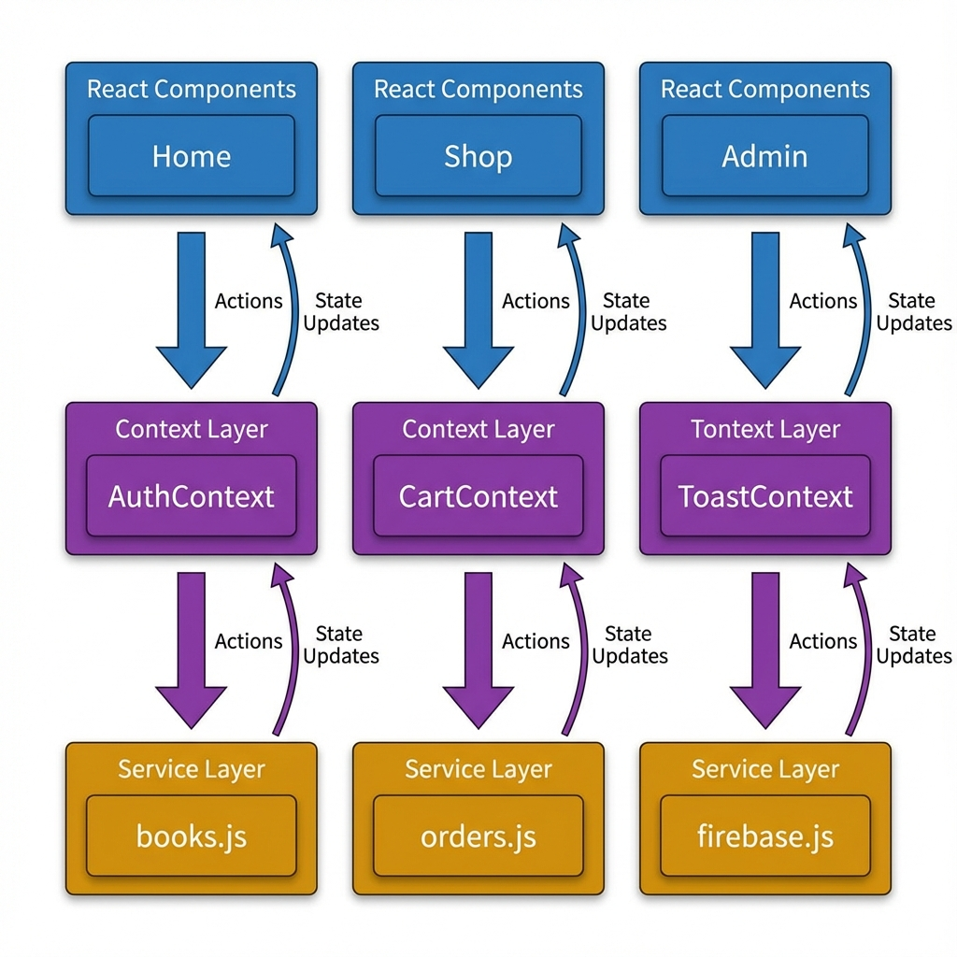

# 🧩 Component Hierarchy

The following tree shows the complete component structure from root to leaf:

**Component Tree**

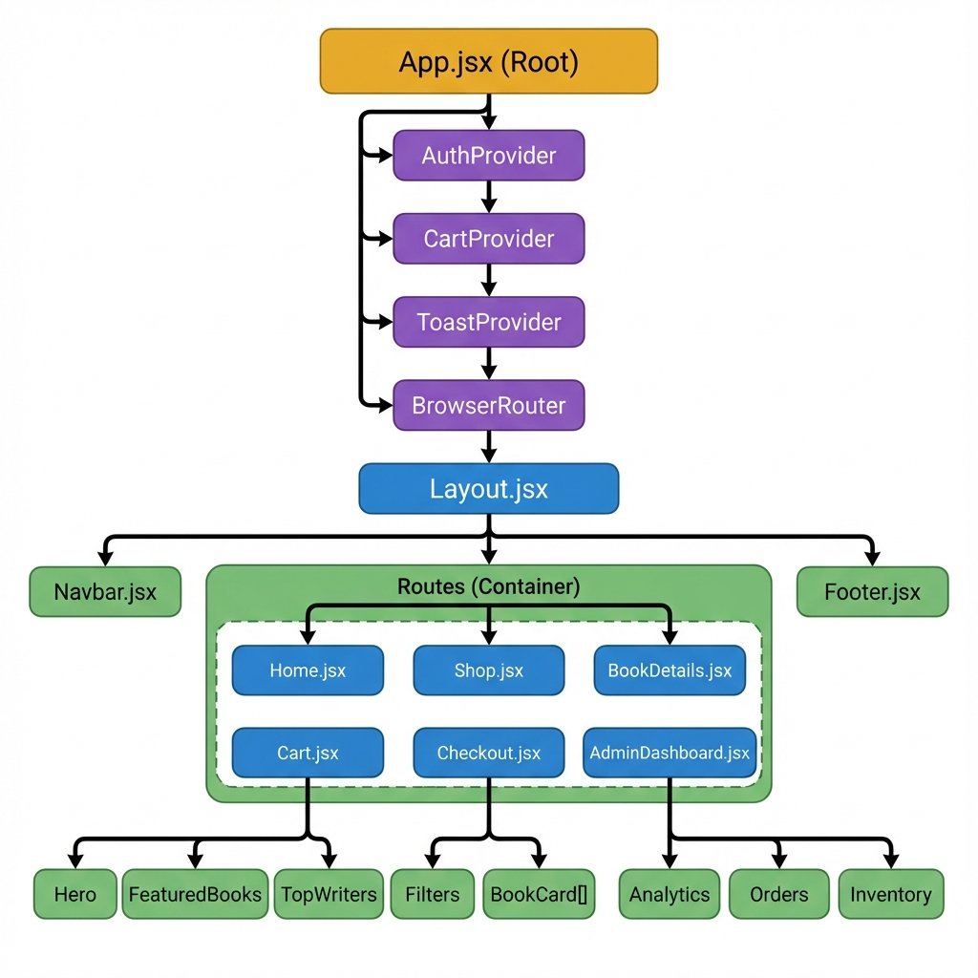

# 🗄️ Database Design (ERD)

The application uses Cloud Firestore with the following collections and relationships:

**Database Schema**

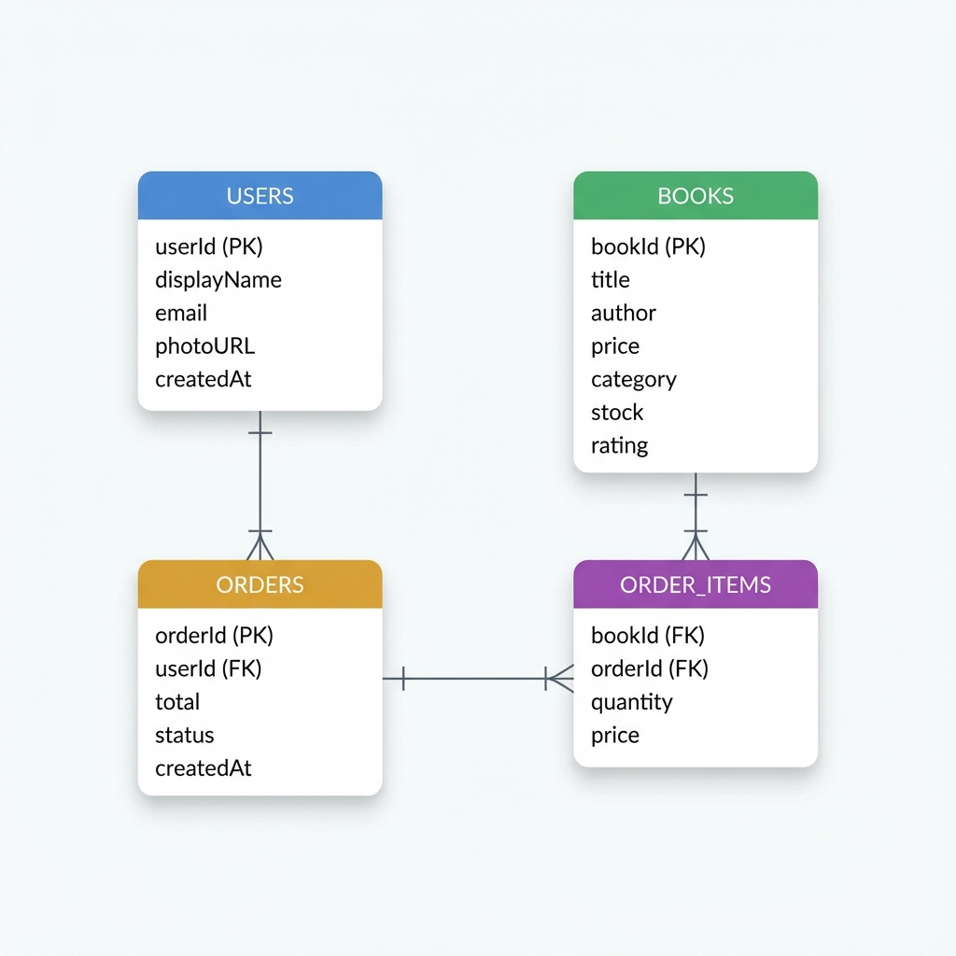

# 🔐 Authentication Flow

The authentication system supports multiple providers with automatic session management:

**Authentication Sequence**

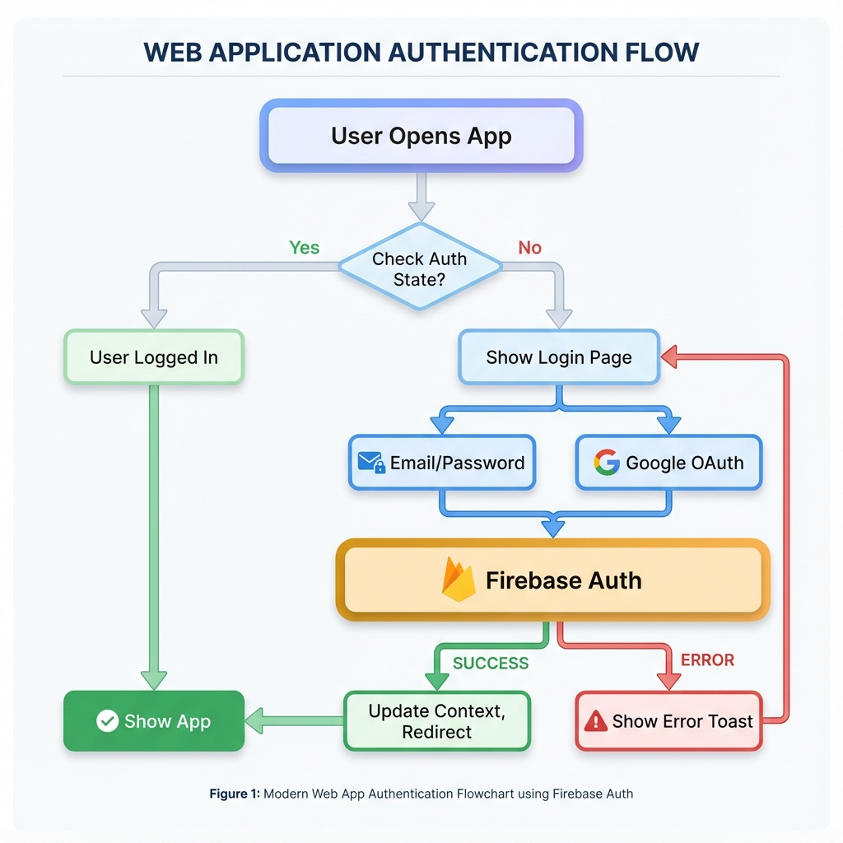

# 📦 Order Processing Flow

The order processing involves multiple steps from cart to delivery:

**Order Processing Sequence Diagram**

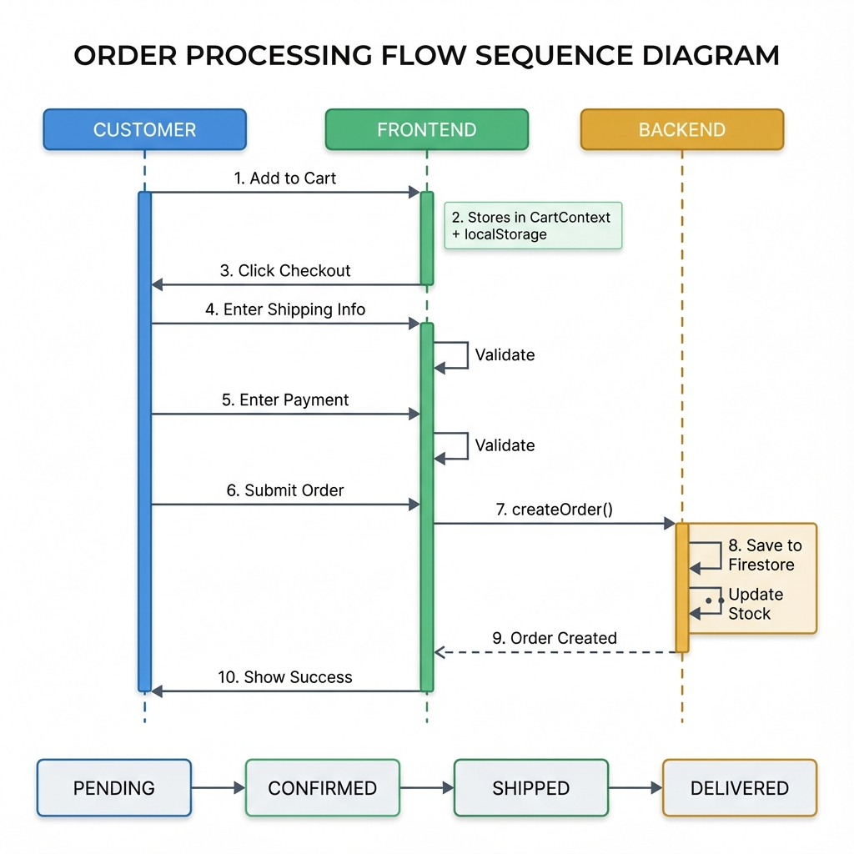

# 📊 Analytics Data System

The analytics dashboard aggregates data from multiple sources to provide business insights:

**Analytics Data Flow**

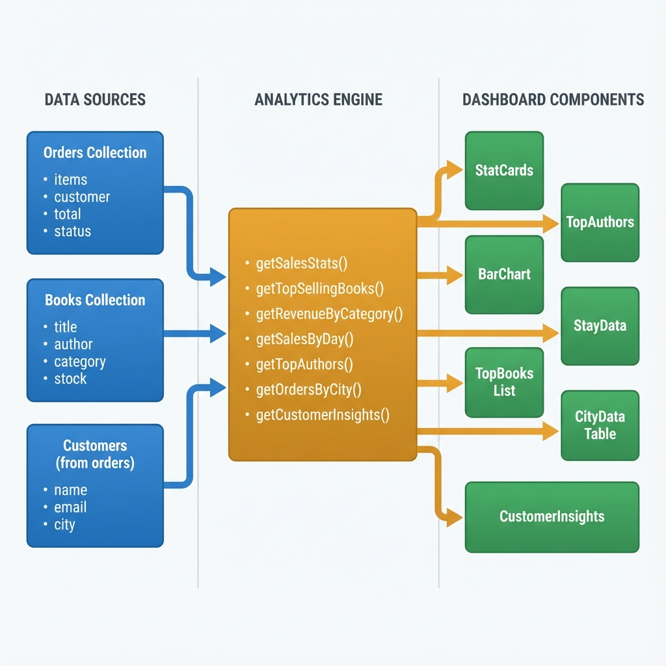

## Analytics Functions Reference

|  |  |  |
| --- | --- | --- |
| **Function** | **Output** | **Purpose** |
| getSalesStats() | totals, counts | Overall business metrics |
| getTopSellingBooks() | ranked books | Identify bestsellers |
| getRevenueByCategory() | breakdown | Category performance |
| getSalesByDay() | daily totals | Revenue trend chart |
| getTopAuthors() | author rankings | Author performance |
| getOrdersByCity() | city data | Geographic insights |
| getCustomerInsights() | metrics | Customer loyalty analysis |

# ⚡ Performance Optimizations

**⚡ Code Splitting:** React.lazy() for route-based code splitting, reducing initial bundle size by loading pages on demand

**⚡ Tree Shaking:** Vite automatically removes unused code from the final bundle

**⚡ Image CDN:** All images served from Unsplash CDN with automatic compression and resizing

**⚡ State Management:** React Context instead of Redux - simpler, less boilerplate, no extra dependencies

**⚡ CSS Optimization:** Tailwind purges unused classes in production, resulting in minimal CSS bundle

**⚡ Database Caching:** Firestore provides automatic client-side caching and offline support

**⚡ Lazy Loading:** Images and components loaded only when needed

**⚡ Minimal Dependencies:** Carefully selected packages to avoid bundle bloat

# 🚀 Future Roadmap

Planned enhancements for future releases:

**Phase 1 - Q1 2025**

☐ Server-side rendering with Next.js for SEO

☐ Razorpay payment gateway integration

☐ Email notifications for order updates

**Phase 2 - Q2 2025**

☐ Wishlist functionality

☐ Book reviews and ratings system

☐ Advanced search with Algolia

**Phase 3 - Q3 2025**

☐ Progressive Web App (PWA) support

☐ Multi-language support (Hindi, Tamil, etc.)

☐ Recommendation engine using ML

──────────────────────────────────────────────────

**CaptBooks Technical Documentation**

By CaptFlag | December 2024

GitHub: github.com/captflag/Online-Book-Store